TINKER
Tools for Molecular Design

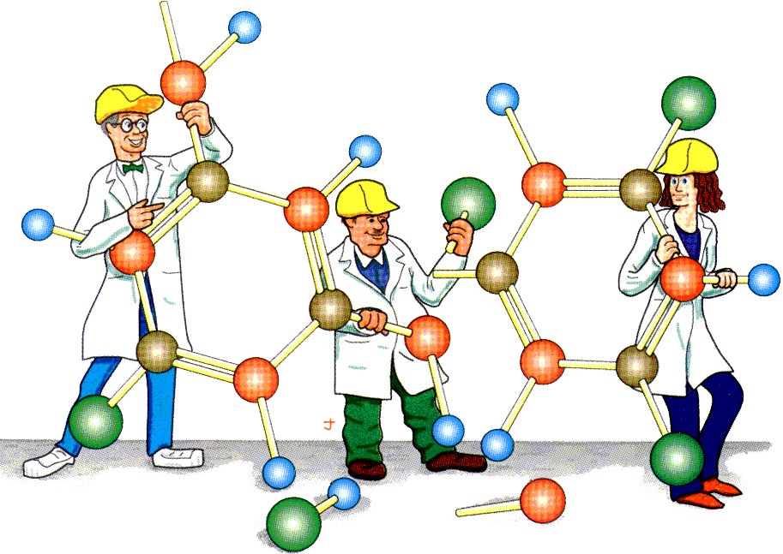

Version 8.11 June 2024

Copyright © 1990-2024
by Jay William Ponder
All Rights Reserved

User's Guide Cover Illustration by Jay Nelson
Courtesy of Prof. R. T. Paine, Univ. of New Mexico

TINKER IS PROVIDED "AS IS" AND WITHOUT ANY WARRANTY EXPRESS OR IMPLIED. THE USER ASSUMES ALL RISKS OF USING THIS SOFTWARE. THERE IS NO CLAIM OF THE MERCHANTABILITY OR FITNESS FOR A PARTICULAR PURPOSE.

YOU MAY MAKE COPIES OF TINKER FOR YOUR OWN PERSONAL, ACADEMIC OR NONPROFIT USE, AND YOU MAY MODIFY THOSE COPIES. YOU MAY NOT DISTRIBUTE ANY ORIGINAL OR MODIFIED SOURCE CODE, EXECUTABLES OR DOCUMENTATION TO USERS AT ANY SITE OTHER THAN YOUR OWN.

PLEASE READ THE FULL TINKER LICENSE, AND SIGN AND RETURN
THE LICENSE AGREEMENT IF YOU MAKE USE OF THIS SOFTWARE.
COMMERCIAL USE OF TINKER IS GOVERNED UNDER A SEPARATE
AGREEMENT AS DESCRIBED IN THE FULL TINKER LICENSE.

V8.11 06/24

