Force Field Explorer
Molecular Engineering Environment

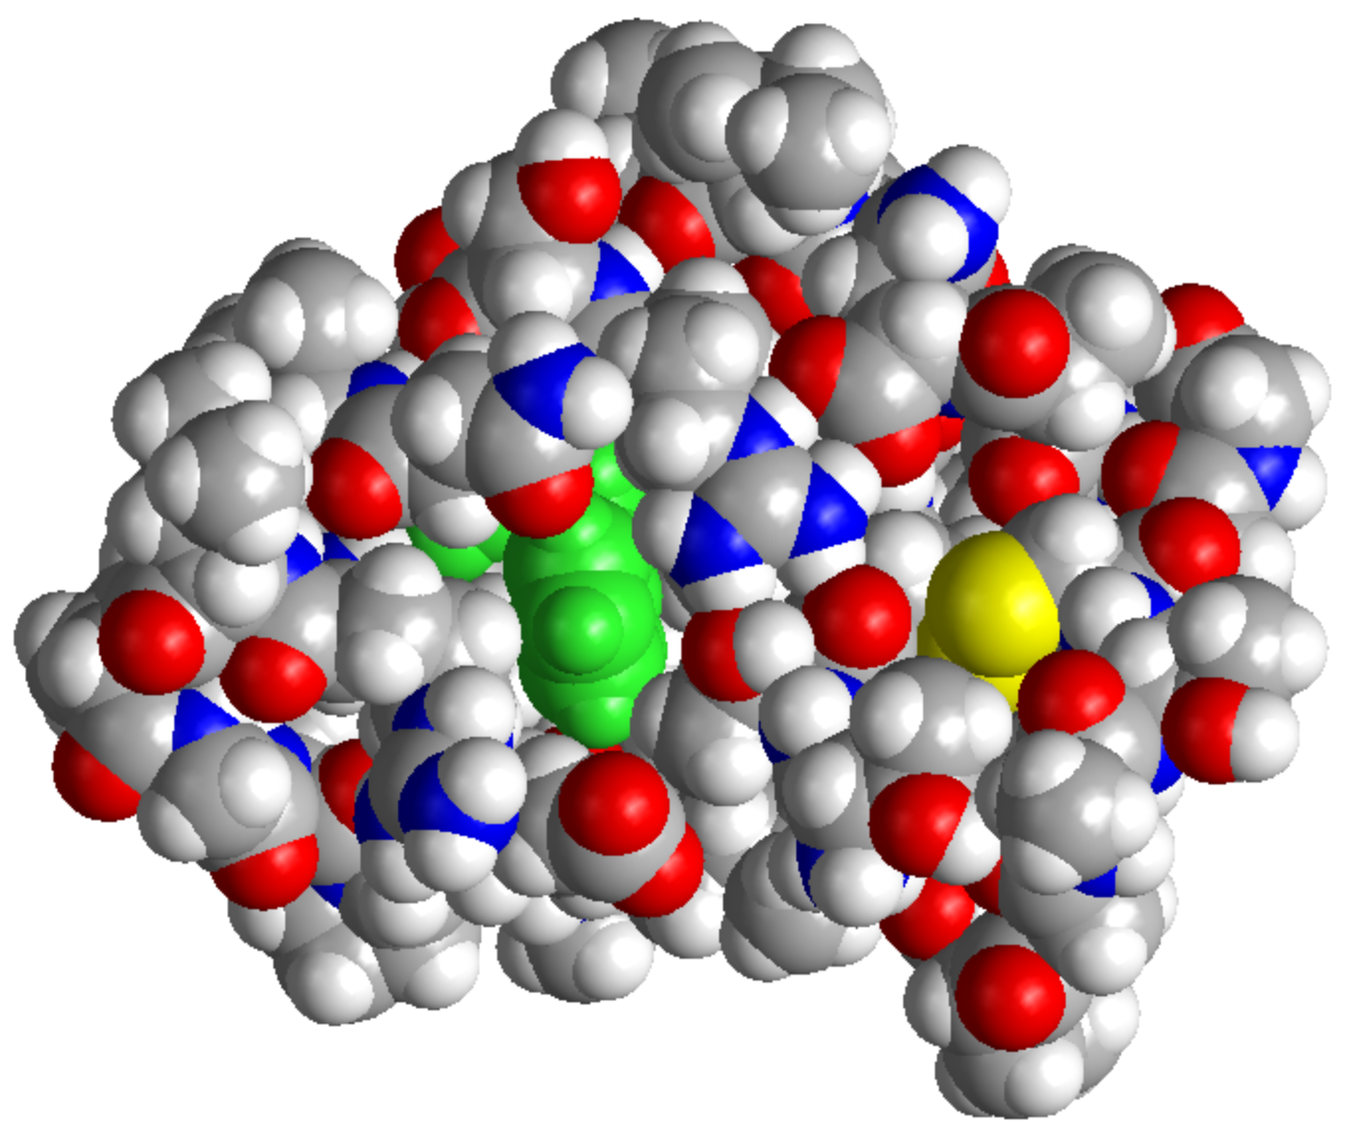
Version 8.10 February 2023

Copyright © 1990-2023
by Michael J. Schnieders & Jay William Ponder
All Rights Reserved

User's Guide Cover Illustration by Jay Ponder
Spacefilled Model of the Crambin Protein (PDB:1CRN)

FORCE FIELD EXPLORER IS PROVIDED "AS IS" AND WITHOUT
ANY WARRANTY EXPRESS OR IMPLIED. THE USER ASSUMES ALL RISKS OF USING THIS SOFTWARE. THERE IS NO CLAIM OF THE MERCHANTABILITY OR FITNESS FOR A PARTICULAR PURPOSE.

YOU MAY MAKE COPIES OF FORCE FIELD EXPLORER FOR
YOUR OWN USE, AND MODIFY THOSE COPIES. YOU MAY NOT DISTRIBUTE ANY ORIGINAL OR MODIFIED SOURCE CODE, EXECUTABLES OR DOCUMENTATION TO USERS AT ANY SITE
OTHER THAN YOUR OWN.

PLEASE READ, SIGN AND RETURN THE TINKER LICENSE
AGREEMENT IF YOU MAKE USE OF THIS SOFTWARE.

V8.10 02/23

